OPERATING SYSTEMS AND SYSTEMS PROGRAMMING

2520030371 – P. HAVISHAA REDDY

PRACTICAL 1&2:

1.
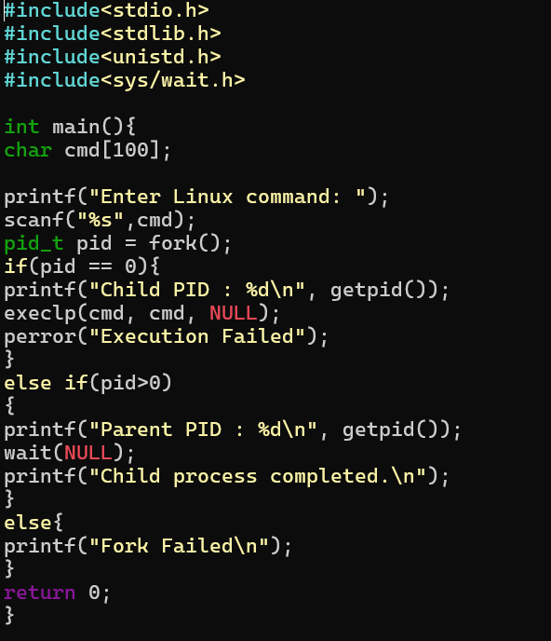

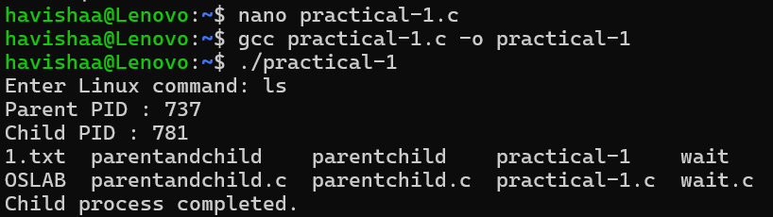

2.

